[Progress Report] Research and fabrication of a motion mimicking hydraulic powered prosthetic arm

# Summary

Upper limb amputees are facing a significant disadvantage in activities of daily living due to the lack of capability and functionality of currently available prosthetics. As such there is a push for stronger, more robust, and versatile prosthetic limbs – characteristics that hydraulic systems are able to provide.

For this project, procurement of all necessary components is almost complete, and the groundwork for the software component has been completed. There are a few remaining pieces of equipment that are still required to obtain, and the 3D print of the prosthetic limb is in progress.

Once all the necessary components have been acquired and fabrication is completed, the project will move ahead to the next stage which involves testing and tuning, and then the final stage which includes expanding and finalising the project.

Table of Contents

Summary 1

Table of Figures 1

Introduction 2

Design Constraints 3

Work Completed 4

Fabrication 4

Structure 4

Power transmission 5

Hydraulic circuit 6

Electrical circuit 6

Procurement 7

Other 8

Software 8

Modelling 9

Work Planned 10

References 11

Appendix 12

# Table of Figures

Figure 1 Architecture for the mechanical drive system based on [1] 4

Figure 2 Initial print (Left), Revised finger joints (Right) 4

Figure 3 Self designed model (Left) vs Hanson Robotics model [26] (Right) 5

Figure 4 Current progress with hand construction 5

Figure 5 Cylinder with potentiometer and potentiometer mount attached 5

Figure 6 Hydraulic block diagram 6

Figure 7 Simplified hydraulic schematic (Complete schematic can be found in Appendix E) 6

Figure 8 First iteration of electrical circuit 7

Figure 9 Microcontroller communications diagram 9

Figure 10 PSoC Top-Level design 9

Figure 11 Single actuator block diagram 9

# Introduction

There are over one million people worldwide who have had some measure of upper limb amputation (Mata Amritanandamayi, Udupa et al. 2018), with a projected one million upper-limb amputees to be living in the United States alone by the year 2050 (Perry, Moran et al. 2018). As a result, there is a continually increasing need for functional prosthetic limbs to assist amputees with activities of daily living as well as physically demanding work.

Being able to perform activities of daily living and aesthetic design are most often seen as the two major decision-making factors when choosing whether or not to use a prosthetic (Piazza, Catalano et al. 2017). However, studies have found that of these two deciding factors, high grip power, grasp versatility, resilience and power autonomy, or, functionality, is generally the dominant design parameter (Piazza, Catalano et al. 2017, Resnik and Klinger 2017). This is due to the important part practicality and functionality play in not only being able to perform specific activities and restoring normality into a person’s life, but also improving the possibility of being reinserted into a job (Proaño-Guevara, Procel-Feijóo et al. 2018). Additionally, a study found that of all adult amputees who were employed prior to the loss of an upper limb, of the percentage that returned to work, the lowest returning percentage were those who worked in physically demanding environments where either the prosthetic solution they were provided with was either unsuitable or too difficult to operate given their circumstances (Millstein, Bain et al. 1985).

The demand for a highly functional prosthesis is supported by the adoption and rejection rates of current prosthesis. Studies have found that between 17% to 80% of people with major upper limb amputation reject the use of a prosthesis entirely because the functional advantage or cosmesis did not outweigh the inconvenience of the prosthesis (Resnik and Klinger 2017, Proaño-Guevara, Procel-Feijóo et al. 2018). A recurring theme presented by amputees is the desire for enhanced strength or grasp force for both myo-electric devices (Piazza, Catalano et al. 2017, Hashim, Abd Razak et al. 2018, Proaño-Guevara, Procel-Feijóo et al. 2018) and body powered devices (Ayub, Villarreal et al. 2017, Hichert, Abbink et al. 2017). For example, for the voluntary closing body powered prosthesis known as the Hosmer Soft Hand, patients had to exert over 131N of cable force in order to achieve a mere 15N pinch force (Hichert, Vardy et al. 2018). A prosthesis powered by dielectric actuators could only achieve 35-97N output force (El-Hamad, Ahmad et al. 2017), and a novel pneumatically powered soft actuator could only achieve 0.46N at 5 bar of pressure (Mata Amritanandamayi, Udupa et al. 2018). To illustrate the issue, a typical anatomically intact bicep can exert 40N-116N worth of force during flexion (El-Hamad, Ahmad et al. 2017). Thus, the need for stronger, more powerful actuators are necessary, such as those that can be offered by hydraulics.

Fluid power has the potential to generate extremely large forces with smaller and more flexible configurations. Durfee, Xia and Hsiao-Wecksler modelled micro hydraulic cylinders, and at a nominal pressure of 6.9MPa (1000psi), a single hydraulic cylinder with a mere 4mm bore can output up to 87N worth of force (Durfee, Xia et al. 2011). Furthermore, the system output is infinitely variable based on the requirements of the user. For example, if more working force is required, either the pressure of the system can be increased, or the size of the cylinders increased and vice versa. If these cylinders were to be implemented, a considerable number of them would be able to fit in the space that would otherwise be taken up by a servo array, allowing far more precise control and freedom of control over the degrees of freedom of the upper limb. If the upper limb was made anatomically correct, there would be three cylinders used for flexion of a single finger which would result in a previously unseen output force per finger than a lot of currently developing prosthetic hands.

Furthermore, Resnik and Hashim have found that weight is a significant contributor to prosthesis adoption (Resnik and Klinger 2017, Hashim, Abd Razak et al. 2018). Significant musculoskeletal issues can be incurred with the use of heavy and unwieldy prostheses, such as excessive discomfort on the stump and noticeable shoulder strain, and if used for extended periods of time may transition into injuries (Abayasiri, Madusanka et al. 2017, Schweitzer, Thali et al. 2018). A majority of externally powered prostheses make use of electrical servo motors in order to actuate the appendages. These prostheses are generally very complex and heavy due to the need of extensive gear trains or drive train mechanisms, and in some cases the placement of a servo motor at every rotational joint (Pai, Sarath et al. 2016). For example, the Modular Prosthetic Limb developed by DEKA weighs approximately 4.8kg with its battery attached (Leal-Naranjo, Ceccarelli et al. 2017). In comparison, an upper limb of a 75kg person typically weighs 3kg (Abayasiri, Madusanka et al. 2017).

Hydraulic powered actuators however do not require the typical power transfer systems in order to operate (Foglyano, Kobetic et al. 2015). It was found that for a 100W mechanical system, an electromechanical system is predicted to weigh 428g. A hydraulic system with equivalent mechanical output weight will change significantly with the pressure of the system. For example, at 0.69MPa (100psi) a 100W mechanical output system is estimated to weigh 625g, at 3.45MPa (500psi) it is estimated to weigh 125g and only 63g at 6.9MPa (1000psi) (Durfee, Xia et al. 2011). This gives significant flexibility in the design to maximise the desired weight to power ratio whilst also providing a significant weight reduction which can aid heavily in the comfort and usability of the device.

Whilst the weight of the arm is extremely important, the distribution of the weight along the arm is equally as important. Additional weight from heavy servo motors and other additional components, especially towards the extremities of the body impacts negatively to the usability of the device. Waters and Mulroy found that an additional weight of 2kg on each foot of a healthy adult results in a 30% increase in oxygen uptake, whilst over ten times that amount on the torso has little impact (Waters and Mulroy 1999). Extending this to the upper limb demonstrates that a poor weight distribution often provided by externally powered prostheses is often hugely detrimental to the benefits that the prostheses strive to provide. For example, the TRS i-Limb (a commercially available prosthetic hand) weighs 0.63kg with a centre of gravity that is fairly distal in comparison to an anatomically intact hand due to the location of the actuators (2015). It was found that this caused significant discomfort on the stump and noticeable shoulder strain during extended use (Schweitzer, Thali et al. 2018).

A key advantage of fluid power is the ability of power to be transported through flexible hosing which can be snaked over moving joints and placed in locations that would otherwise be impractical for electrical motors. This characteristic provides great flexibility in component placement such as placing the hydraulic cylinders on the proximal joints (Durfee, Xia et al. 2011), and the other heavier components such as the pump, valves and battery may be kept on the torso where they cause a considerably lesser strain on the body (Foglyano, Kobetic et al. 2015). Furthermore, this flexibility can be leveraged for numerous additional benefits. By being able to choose the location of the actuators, they can be optimised for maximum benefit. Placing the actuators away from the joints of the fingers and closer to the shoulder aids in reducing the rotational inertia (Leal-Naranjo, Ceccarelli et al. 2017) which allows greater control over the arm and reduced power requirements in order to operate it. This also allows the end effector or the hand to be minimised to further reduce the weight (Semasinghe, Ranaweera et al. 2018), as a prosthetic hand weighing 0.5kg or more tends to lead to overexertion (Proaño-Guevara, Procel-Feijóo et al. 2018). Power then can be transmitted to the distal joints via tendon or cables – a technique used often in prosthetics to gain similar benefits (Love, Lind et al. 2009).

There is a clear need for stronger and more powerful, yet lighter and more robust prosthetic devices, which can be catered to by hydraulics. These benefits combined with its flexible component configuration as well as its force-to-weight ratio have the potential to develop a revolutionary prosthetic design. It will be another step in the direction to allow amputees and similarly disadvantaged persons to mitigate the adverse effects of upper limb loss and enable them to retain or regain their standard of living.

The aim of this project is to explore the use of hydraulics in upper limb prostheses - to identify its practicality and feasibility in the field. The goal is to rapidly prototype an anthropomorphic prosthetic arm with a high and demonstrable degree of freedom using readily available and off-the-shelf components.

## Design Constraints

The reason for developing an anthropomorphic style prosthetic arm is due to aesthetic and degree of anthropomorphism being seen as one of the most important characteristics that a prosthetic system should exhibit. Aesthetic plays a crucial role in the psychological wellbeing and social acceptance of amputees (Piazza, Catalano et al. 2017). It is one of the main reasons why many amputees opt for an externally powered prosthesis, and one of the reasons why the gap of usage between powered and unpowered devices is so large (Hashim, Abd Razak et al. 2018). Whilst it is challenging to develop an anthropomorphic and anatomically correct system based on musculoskeletal systems (Proaño-Guevara, Procel-Feijóo et al. 2018), there is no reason to develop a prosthetic system if the adoption rates will be extremely low.

Being a rapid prototyping project, the goal is to use as many off-the-shelf and ready-made components as possible. However, micro hydraulic systems tend to be expensive and not readily available. There has been research and development in the field of micro hydraulic fluids, such as a minimal weight and wearable hydraulic power supply (Nath and Durfee 2017) and alternative actuator designs such as soft fluid power actuators (Polygerinos, Wang et al. 2015) or nested hydraulic cylinders (Yong, JunHong et al. 2015). These systems however are all just prototypes and thus it is not easy or affordable to obtain these for the purpose of this project. The ideal actuators to use for this prosthetic design are mesofluidic actuators such as those used in (Love, Lind et al. 2009). Limiting the project to what can be purchased relatively easily considerably restricts the capability and effectiveness of the prosthetic (manufacturing low tolerance actuators is slow and expensive) however it should still be sufficient to demonstrate the benefits of the design.

# Work Completed

## Fabrication

Fabrication of the prosthetic arm structure began almost immediately. Figure 1 illustrates the layout of the entire system. It has been based on (Durfee, Xia et al. 2011) who developed a hydraulic system for an orthotic device.

Motion Controller

Computer

PWM Driver

Servo motor

Valve

Conduit

Cylinder

Pump

Figure 1 Architecture for the mechanical drive system based on (Durfee, Xia et al. 2011)

All components prior to the valve represent the power supply and control components. The ‘Conduit’ block represents the power transmission line, and the ‘Cylinder’ block represents the actuator.

### Structure

Initially we had opted to develop our own prosthetic arm structure so that we could optimise it for our actuation method. The model would be based off Thieme’s Atlas of Anatomy (Organ 2008) which provided an in-depth insight into the structure of the upper limb. We had decided to model all 22 DoF initially, which led to an initial design seen in Figure 2. After the initial print we then determined that we would remodel the joints such that they were designed as single degree of freedom joints for ease of actuation for an initial prototype (Figure 3 left). The metacarpal bones were designed to be separate such that if we wished to implement the abduction and adduction of fingers, there would be room for the actuators in the anatomically correct locations. We determined however that achieving anatomically correct abduction and adduction would be impossible with the components we could acquire if we wished to retain complete hydraulic actuation.

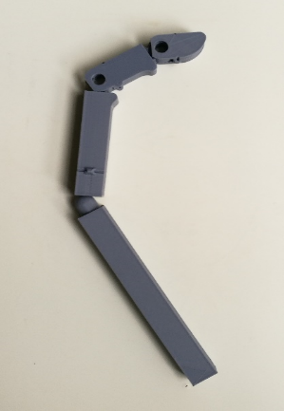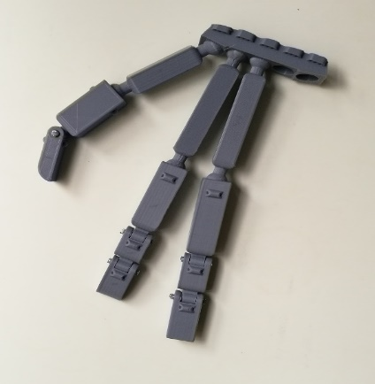

Figure 2 Initial print (Left), Revised finger joints (Right)

After numerous hours of 3D modelling, we decided that designing our own prosthetic arm would take too much time for the project duration, and thus opted to take and adapt an externally made prosthetic arm for our actuation method (Figure 3 right). This prosthetic arm was made and developed by a company called Hanson Robotics for the Sophia Robot Project (Morales 2018).

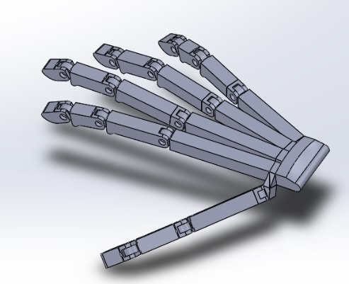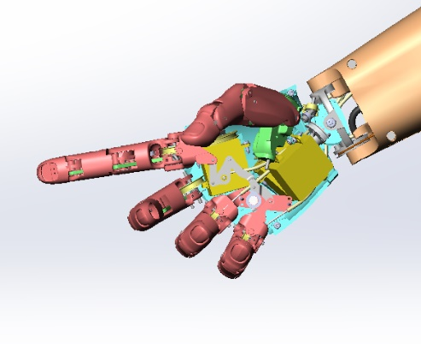

Figure 3 Self designed model (Left) vs Hanson Robotics model (Morales 2018) (Right)

Trial prints of the prosthetic hand has begun (Figure 4), and we are currently attempting to assemble the hand to better identify Hanson Robotics’s method of power transmission, and then adapt it for our own purposes. As per our project plan, we will be constructing just the index finger initially and actuating that before expanding our design.

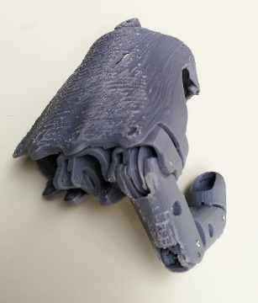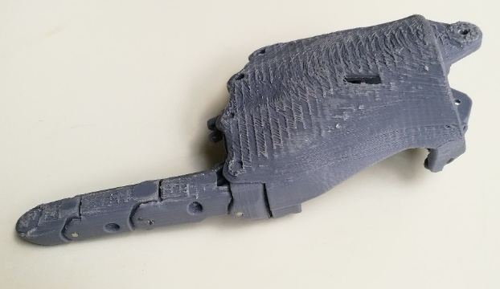

Figure 4 Current progress with hand construction

The forearm at the moment is out of our present scope, and as such we will use an arbitrarily simple structure to mount our actuators, so that we can perform testing and tuning on our system.

In order to mount the position sensors (slide potentiometers) to each individual cylinder, a two-component mounting structure was designed. It was designed to mount directly onto the cylinders themselves to minimise the space requirements (Figure 5).

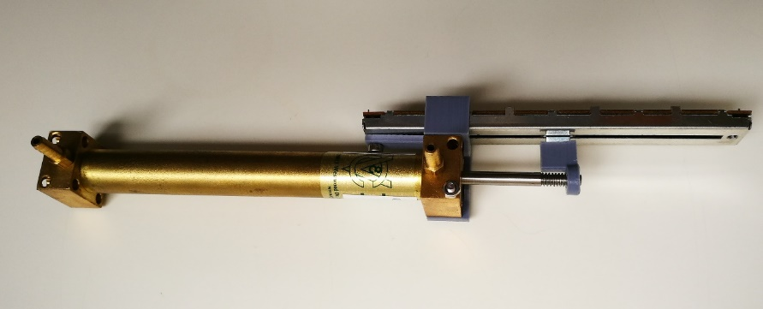

Figure 5 Cylinder with potentiometer and potentiometer mount attached

### Power transmission

We have opted to follow Kontoudis’s recommendation in using elastomeric materials to perform digital extension, whilst using cables attached to the actuators for flexion (Proaño-Guevara, Procel-Feijóo et al. 2018). For the cable component we have chosen to use braided steel wire which should be strong enough for the amount of tension we will be supplying to the system. Whilst it is known that there is power loss from friction for cable transmissions (Hichert, Abbink et al. 2017, Semasinghe, Ranaweera et al. 2018), we believe that given our actuation method these losses should be insignificant for demonstrative purposes. If necessary we could employ friction reducing materials such as Teflon liners to improve the efficiency of power transfer as suggested by Hichert (Hichert, Abbink et al. 2017). For the elastomeric materials component, we have decided to use torsion springs installed internally into the joints, as this has already been catered for in Hanson Robotics’s design. This will allow extension as when the actuator extends, slack appears in the cable which is picked up by the torsion springs.

### Hydraulic circuit

The hydraulic requirements for the system is very simple. It is a basic pump, actuator, and directional control valve configuration. The block diagram of this system can be found in Figure 6, a simplified schematic in Figure 7, and the complete schematic in Appendix E.

Pump

Pump

Valves

Valves

Conduit

Conduit

Cylinder

Cylinder

Figure 6 Hydraulic block diagram

Our system is pressure limited due to the budget we have to work with. As such, the pressure limiting device is the valves which are designed to be operated at a working pressure of 18 bar, and a maximum pressure of 30 bar. Therefore, the maximum output force of the system will never be reached due to this limitation. If we can reach our theoretical maximum pressure in the cylinders, we would be able to achieve an output force of around 89N.

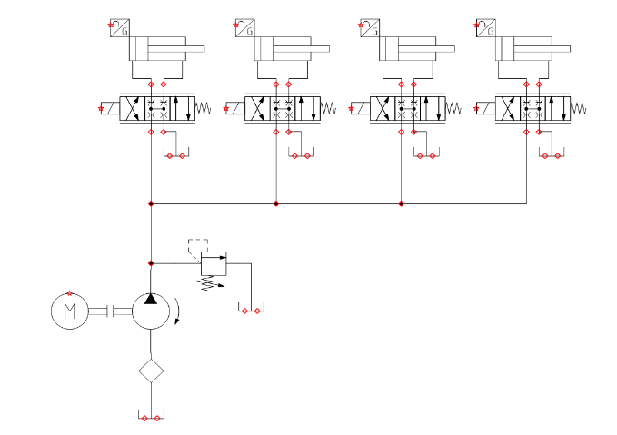

Figure 7 Simplified hydraulic schematic (Complete schematic can be found in Appendix E)

We have completely determined all the specific components required to complete the hydraulic component of the fabrication. In particular we require 3/8” BSP Port to 4mm fittings and 4/2.5mm nylon hosing. Once these are acquired the hydraulic circuit can be completed and testing can commence.

### Electrical circuit

The original electrical circuit was designed as seen in Figure 8. This was designed with the assumption that we would be able to acquire hydraulic solenoid proportional valves, magnetic cylinder position sensors and a suitable USB to GPIO module. However, the solenoid proportional valves and magnetic cylinder position sensors were priced in such a way that we would not be able to afford a reasonable quantity for the purpose of this project, coming at around $1000 per valve and $300 per sensor. The USB to GPIO module could not satisfy the criteria we required as the maximum switching frequency would not be able to provide a suitable PWM signal for control.

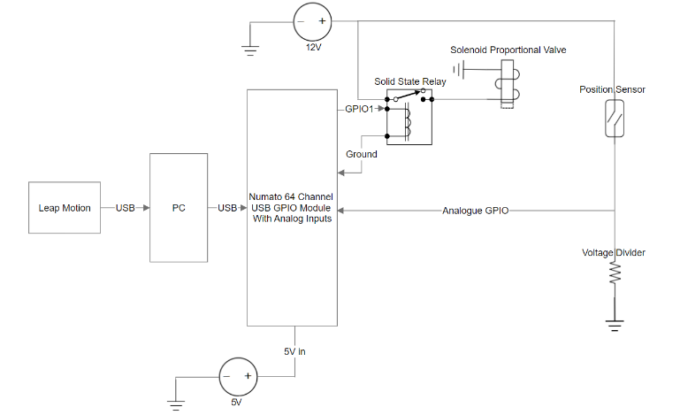

Figure 8 First iteration of electrical circuit

Thus, we have opted for servo proportional valves, slide potentiometers and a PSoC. This slightly modifies the previous electrical circuit, and whilst cheaper, provides us with sufficient capability to control the prosthetic arm.

## Procurement

The components required to construct this prototype are as follows:

* Hydraulic power unit
* Directional control valves
* Hydraulic oil
* Hydraulic hosing and fittings
* Servo motors
* Programmable system on a chip (PSoC)
* Computer
* Leap Motion Controller
* Hydraulic cylinders
* Tendons
* Elastic elements (i.e. torsion spring or elastomeric materials)
* Position sensor
* Relays

Due to the nature of the project, the project is personally funded. This has resulted in the need to obtain affordable hydraulic components, which is generally not very possible based on the current state of the hydraulics industry. This means that relationships would need to be developed with manufacturers and distributors in order to make the project possible. We approached numerous different hydraulics companies to see whether or not arrangements could be made for either discounts or hire of the equipment we needed.

Of the companies contacted, we managed to develop beneficial relationships with three major companies: Hydac, a major hydraulic component manufacturer and distributor; Valvoline, a major oil manufacturer and distributor; and Hydraulink, a medium sized hydraulic hosing and coupling distributor. Smaller benefits were obtained from: Cylinders & Valves Incorporated, a hydraulic cylinder manufacturer; Numato Lab, an industrial control and automation manufacturer; and SICK, an industrial sensor manufacturer.

Hydac has offered to provide an entire power unit for the purpose of our project for no charge. They will be installing the power unit with a 1.1kW motor and a 50L reservoir which should be sufficient for our purposes, however as it is an industrial company, their motor will require a three-phase power supply. They are also providing four directional control valves which will reduce the cost of the project significantly. Their contribution is worth approximately $2000.

Valvoline has agreed to provide as much hydraulic oil as necessary for the purpose of this project. As of the moment we have obtained 60L of ISO 32 grade hydraulic oil at no cost to us. We have chosen ISO 32 based on the specifications of the pump to ensure the best operation for a reasonable duration. Their contribution is worth approximately $400.

Hydraulink had previously agreed to supply hosing and fittings for our project in the event that they were able to obtain the suitable components for the project. However once we have completely specified our system their state manager determined they were no longer able to assist due to the size of the conduits we required. We are currently establishing alternative methods to obtain the required hosing and fittings.

Cylinders and Valves Incorporated agreed to provide a 20% subsidy to any purchases made through them. We have purchased four 10mm bore cylinders from them, with that discount. Their discount is worth approximately $60.

Numato Labs have provided a generous discount for their products which equated to about 40%. We have purchased a USB to GPIO module with the intention to control the large valves that Hydac have provided via solid state relays. Their contribution is worth approximately $120.

SICK has offered considerable discounts on their industrial grade sensors. They have offered an approximately 40% concession on their sensors, however after some initial testing of cheap position sensors, their sensors may not entirely be necessary (refer to Appendix A). At $100-$200 per sensor after discount, a large amount of consideration must be applied before pursuing these premium sensors.

Of the remaining components, the directional control valves, servo motors, PSoC, Leap Motion Controller, steel wire, elastic elements, position sensors and relays have all been acquired.

## Other

The dangers of operating a hydraulic system has been made extremely clear to us. Hydac, as part of their contribution offered to provide an accredited and certified training course in order to educate us both about hydraulic systems and how to safely operate them free of charge. We decided to undertake this training course as we understand the safety of persons near and operating the device is of utmost concern. We are now both certified in Basic Hydraulics 1, accredited by the KANGAN institute which provides us with the skills and knowledge to operate simple hydraulic systems safely.

We have also completed the safety induction for the Laboratory for Motion Generation and Analysis, to ensure that we are aware of the safety procedures concerning the lab to ensure the safety of everyone inside the building and the lab itself.

## Software

We have decided to use GitHub as a version control and development tool through the duration of this project. All code written and developed in this project will be uploaded to GitHub (Robinson and Vuong 2018). This allows us to track changes, roll back code if issues develop, and have access to the code from anywhere.

The framework for using the microcontrollers in the system has been completed, establishing communications between all microcontrollers, sensors and actuators in the system. The program has been programmed in C++. It communicates between microcontrollers in a call-response manner.

Leap Motion

Leap Motion

CPU

CPU

PSoC

PSoC

Figure 9 Microcontroller communications diagram

We have currently obtained a communications frequency of around 40Hz, that is 40 calls and responses per second. Though this limitation is software side and can be improved with optimisation.

The microcontroller purposes are as follows. The leap motion controller pulls position information from the orientation of the reference hand. This is communicated to the main computer which processes the information to determine the angle of the joints. This is compared against the current position of the joints which is detected by the PSoC. The error is then calculated by the computer and a new valve position is pushed to the PSoC.

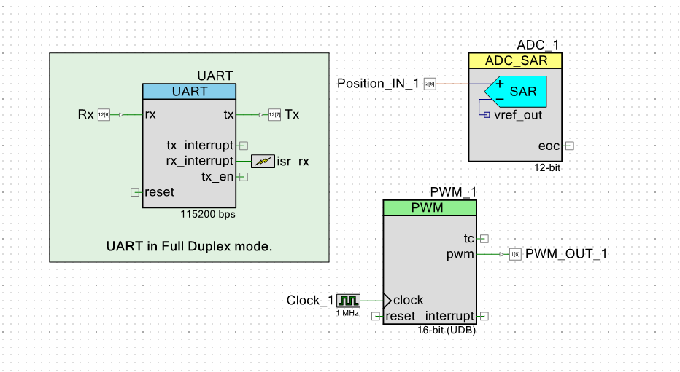

Figure 10 PSoC Top-Level design

The PSoC code is designed to be minimal and light weight in order to achieve low latency response times. The top-level design is seen in Figure 10 which illustrates this as there are only three major components programmed.

### Modelling

Preliminary steps for modelling the system has begun. The block diagram for a system with a single actuator is illustrated in Figure 11.

Figure 11 Single actuator block diagram

1/s

1/s

Where:

The PID controller is defined by:

The plant formula uses the assumption that the system will maintain constant pressure and uses the following formulas:

Where:

The position to joint angle converter currently only has a fill in variable which represents the relationship between the two variables. This will have to be calculated after fabrication of the relevant joints are completed. It will be different for every joint.

# Work Planned

The overall outcomes for this project are to build a controllable prosthetic arm using hydraulic actuation which mimics a person’s hand with data from a LEAP motion controller. Going forward, acquisition of all components needs to be prioritised as currently this is causing a delay in the project. Appendix B and C show that the lack of a working system is hindering the progress of Stage 2. Missing components include hosing, coupling and the pump. Once these parts are acquired the system will be assembled, and Stage 2 can be quickly completed as the groundwork for Stage 2 has already been completed. Thus, it can be expected that work can commence on Stages 3 (Appendix C) and 4 (Appendix D) relatively soon.

Continued delays for this project can be caused by further issues procuring components, as working with external companies can cause significant delays as providing assistance free of charge often ranks extremely low on their priority lists.

Possible causes of failure are if the pump or proportional valves are unable to supply the necessary amount of pressure and actuation speed required to keep up with the reference input, or, previously unforeseen issues with the reference information from the motion controller. This may force a re-evaluation of the project scope in order to match what is achievable with the available equipment.

The focus after we have obtained all components will be to begin tuning the controller for the actuators for an ideal response, i.e. zero overshoot and fast rise time and setting time. Tuning will begin with the Ziegler-Nichols tuning method as well as a separate theory-based model based on the control system we identify in Figure 11. Using a combination of theory and experimental methods to tune the PID should hasten the process.

# References

(2015). Touch Bionics Product Catalogue. Massachusetts, Touch Bionics**:** 4.

Abayasiri, R. A. M., et al. (2017). MoBio: A 5 DOF trans-humeral robotic prosthesis. 2017 International Conference on Rehabilitation Robotics (ICORR).

In this paper, a 5 DOF trans-humeral robotic prosthesis: MoBio is proposed. MoBio includes 2 DOF at wrist which is rare in other trans-humeral prostheses. Through anthropometric features MoBio prosthetic arm can achieve elbow flexion/extension, forearm supination/pronation, wrist radial/ulnar deviation, wrist flexion/extension and compound motion of thumb and index finger. An EMG based control method which uses EMG signals of the biceps brachii and triceps brachii, is used with a motion switching mechanism to control the prosthesis. Experimental results have verified the usability and effectiveness of MoBio in performing Activities of Daily Living.

Ayub, R., et al. (2017). "Evaluation of transradial body-powered prostheses using a robotic simulator." Prosthetics and orthotics international **41**(2): 194-200.

Background:Transradial body-powered prostheses are extensively used by upper-limb amputees. This prosthesis requires large muscle forces and great concentration by the patient, often leading to discomfort, muscle fatigue, and skin breakdown, limiting the capacity of the amputee to conduct daily activities. Since body-powered prostheses are commonplace, understanding their optimal operation to mitigate these drawbacks would be clinically meaningful.Objectives:To find the optimal operation of the prosthesis where the activation force is minimized and the grip force is maximized.Study design:Experimental design.Methods:A computer-controlled robotic amputee simulator capable of rapidly testing multiple elbow, shoulder, and scapular combinations of the residual human arm was constructed. It was fitted with a transradial prosthesis and used to systematically test multiple configurations.Results:We found that increased shoulder flexion, scapular abduction, elbow extension, and the placement of the ring harness near the vertebra C7 correlate with higher gripper operation efficiency, defined as the ratio of grip force to cable tension.Conclusion:We conclude that force transmission efficiency is closely related to body posture configuration. These results could help guide practitioners in clinical practice as well as motivate future studies in optimizing the operation of a body-powered prosthesis.Clinical relevanceThe results from this study suggest that clinicians ought to place the ring harness inferior and to the sound side of the vertebra prominens in order to maximize grip efficiency. The results will also help clinicians better instruct patients in body posture during prosthesis operation to minimize strain.

Durfee, W., et al. (2011). Tiny hydraulics for powered orthotics. 2011 IEEE International Conference on Rehabilitation Robotics.

Untethered, powered orthotics require an actuation system with power supply and control, transmission line and actuator. Fluid power has unmatched force-to-weight and power-to-weight compared to electromechanical systems, but it is unclear if those same advantages hold for small systems in the 10 to 100 W range. A systems analysis approach suggests that a fluid power system will be lighter than an electromechanical system with the same output power and efficiency if the fluid power is run at pressures over about 200 psi. A theoretical analysis of small bore cylinders suggests that eliminating the piston seal will result in a higher efficiency actuator if the clearance gap is small. A demonstration, battery powered electrohydraulic actuator assembled from off-the-shelf components had the force and power suited to a powered ankle orthosis, but is too large and too heavy, suggesting the need to develop custom components.

El-Hamad, H. J., et al. (2017). "Modelling of High Output Force Dielectric Elastomer Actuator." International Journal of Mechanical Engineering and Robotics Research **6**(2): 100-103.

Foglyano, K. M., et al. (2015). "Feasibility of a Hydraulic Power Assist System for Use in Hybrid Neuroprostheses." Applied Bionics and Biomechanics **2015**: 205104.

Feasibility of using pressurized hydraulic fluid as a source of on-demand assistive power for hybrid neuroprosthesis combining exoskeleton with functional neuromuscular stimulation was explored. Hydraulic systems were selected as an alternative to electric motors for their high torque/mass ratio and ability to be located proximally on the exoskeleton and distribute power distally to assist in moving the joints. The power assist system (PAS) was designed and constructed using off-the-shelf components to test the feasibility of using high pressure fluid from an accumulator to provide assistive torque to an exoskeletal hip joint. The PAS was able to provide 21 Nm of assistive torque at an input pressure of 3171 kPa with a response time of 93 ms resulting in 32° of hip flexion in an able-bodied test. The torque output was independent of initial position of the joint and was linearly related to pressure. Thus, accumulator pressure can be specified to provide assistive torque as needed in exoskeletal devices for walking or stair climbing beyond those possible either volitionally or with electrical stimulation alone.

Hashim, N. A., et al. (2018). "Improvement on upper limb body-powered prostheses (1921–2016): A systematic review." Proceedings of the Institution of Mechanical Engineers, Part H: Journal of Engineering in Medicine **232**(1): 3-11.

Hichert, M., et al. (2017). "High Cable Forces Deteriorate Pinch Force Control in Voluntary-Closing Body-Powered Prostheses." PLoS ONE **12**: e0169996.

Hichert, M., et al. (2018). "Fatigue-free operation of most body-powered prostheses not feasible for majority of users with trans-radial deficiency." Prosthetics and orthotics international **42**(1): 84-92.

Leal-Naranjo, J. A., et al. (2017). Mechanical Design of a Prosthetic Human Arm and its Dynamic Simulation, Cham, Springer International Publishing.

In this paper the mechanical design of a prosthetic human arm with 7 DOFs that includes the shoulder, elbow and wrist is presented. The objective of this design is to have an anthropomorphic, functional and low cost prosthesis. A set of dynamic simulations were performed to determine the feasibility of the mechanism as well as the torque required to perform the activities. The results show that the design could be a good solution due to the physical characteristics and the kinematic of the system.

Love, L. J., et al. (2009). Mesofluidic actuation for articulated finger and hand prosthetics. 2009 IEEE/RSJ International Conference on Intelligent Robots and Systems.

Mata Amritanandamayi, D., et al. (2018). "A novel underactuated multi-fingered soft robotic hand for prosthetic application." Robotics and Autonomous Systems **100**: 267-277.

Robotic hand plays a very important role as it is required to hold and place the object at the desired location. There has been a lot of research on the flexible pneumatic rubber or polymer based actuators for soft gripper applications. This paper is investigating asymmetric bellow flexible pneumatic actuator (ABFPA) as a bending joint made of suitable rubber material in the construction of a novel underactuated multi-jointed, multi-fingered soft robotic hand for prosthetic application. The proposed asymmetric actuator has a single internal chamber and is simple, compact and easy to manufacture. Several actuator designs are analyzed and validated experimentally. It is found that the effect of shape and eccentricity of the ABFPA plays an important role in the bending of the actuator. By proper selection of materials and manufacturing of the ABFPA with reinforcement, a versatile dexterous hand can be fabricated. The present work has paved the way for extensive research on this innovative technique as it holds out the true potential for innumerable and very interesting application in various areas.

Millstein, S., et al. (1985). "A review of employment patterns of industrial amputees—factors influencing rehabilitation." Prosthetics and orthotics international **9**(2): 69-78.

More than 1,000 industrial amputees at the Ontario Workers' Compensation Board were reviewed. The study investigated the current employment status of amputees and the factors that influenced successful return to work post-amputation. The data obtained from a mailed questionnaire was analysed by the Statistical Analysis System. The results revealed that 89% of amputees returned to work after an amputation. The average follow-up post-amputation was 14 years with a range of one to 64 years. At the time of review the current employment status of amputees was as follows: 51% full time employed, 5% part-time employed, 25% retired and 8% unemployed. The remainder were engaged in a vocational activity, still recovering or were not seeking work. The data revealed that amputees typically changed jobs when returning to the work force. Amputees returned to jobs that were less physically demanding, but required greater intellectual skills in occupations such as clerical and service industries. Factors including prosthetic use, vocational services, and a younger age at the time of amputation were identified as being positively associated wth a return to work. Those factors that were negatively related to successful employment included stump and phantom limb pain and multiple limb amputations. The study concluded that the majority of the amputees reviewed were successful in returning to work. The authors suggest that amputees benefit from treatment programmes that include medical, prosthetic and vocational services.

Morales, G. (2018). "Anthropomorphic Robot Hand and Arm CAD Model."

Nath, J. D. and W. K. Durfee (2017). "Optimization and Design Principles of a Minimal-Weight, Wearable Hydraulic Power Supply." (58271): V001T030A002.

The field of wearable hydraulics for human-assistive devices is expanding. One of the major challenges facing development of these systems is creating lightweight, portable power units. This project’s goal was to develop design strategies and guidelines with the use of analytical modeling to minimize the weight of portable hydraulic power supplies in the range of 50–300 W. Steady-state, analytical models were developed and validated for a system containing a lithium-polymer battery, brushless DC motor, and axial-piston pump. Component parameters such as motor size, pump size, and swashplate angle were varied to explore and develop four main design guidelines that can be used by designers to minimize overall system weight. First, it is often not beneficial to select the smallest sized electric motor that can provide the required torque and speed. Second, cooling systems generally do not help reduce overall system weight. Third, the gearbox between the electric motor and pump should be eliminated to reduce system weight. Fourth, iterative modeling is necessary to determine the various range of particular component parameters necessary to result in a minimal-weight system. The analytical model developed takes inputs of desired flowrate, pressure, and runtime, and outputs the combination of pump size, swashplate angle, and motor size that results in a minimal-weight system. The four design principles and the computer simulation are tools that can be used to either design a fully custom, weight-optimized power supply or to aid in the selection of commercially available components for a low-weight power supply.

Organ, J. M. (2008). "Thieme atlas of anatomy: General anatomy and musculoskeletal system thieme atlas of anatomy: neck and internal organs." JAMA **299**(2): 220-226.

Pai, U. J., et al. (2016). Design and manufacture of 3D printec myoelectric multi-fingered hand for prosthetic application. 2016 International Conference on Robotics and Automation for Humanitarian Applications (RAHA).

Multi-fingered robotic hand plays a very important role as it is required to hold and place the object at the desired location. Extensive research work is under way in the design of Multi fingered or anthropomorphic hand. Exhaustive survey of all such hands convey the idea of higher and higher sophistication with innumerable components and elaborate controls with programmable ability has been the outcome of research. In this paper, we present an innovative design, simple to manufacture and low cost 3D printed myoelectric multi-fingered hand for prosthetic application. Servomotors coupled with pulleys and strings are used for actuation of fingers. This prosthetic hand is developed to study trans-radial amputees. The hand features human like fingers along with thumb roll mechanism which is driven by low weight servo motors. The hand is controlled by Arduino nano whose signal is powered by myoelectric sensor and the whole circuit is powered by 12V rechargeable battery. The fabricated hand is tested to study some of the human grasps by imitating the human actions and the results are presented.

Perry, B. N., et al. (2018). "Initial Clinical Evaluation of the Modular Prosthetic Limb." Frontiers in Neurology.

Piazza, C., et al. (2017). "The SoftHand Pro-H: A Hybrid Body-Controlled, Electrically Powered Hand Prosthesis for Daily Living and Working." IEEE Robotics and Automation Magazine **24**(4): 87-101.

Polygerinos, P., et al. (2015). "Soft robotic glove for combined assistance and at-home rehabilitation." Robotics and Autonomous Systems **73**: 135-143.

Proaño-Guevara, D., et al. (2018). Biomimetical Arm Prosthesis: A New Proposal, Cham, Springer International Publishing.

In Ecuador, as in the world the most commonly used prostheses are only aesthetic, and the problem with the people that uses them is that they don’t feel fully comfortable and independent with their activities, so in looking for solving this problem, researchers have designed different active prostheses but as the technology advances, these equipment gets more complex, heavy and expensive, so the people who need them doesn’t feel acceptance. The goal of this and the further investigations is development of a new design that can properly integrate the top technologies in a skeletal design which makes natural movements and will improve the quality of life of the people who uses it. This paper analyses the different designs on the available prosthesis and extract from them the best characteristics of the upper limb prostheses design.

Resnik, L. and S. Klinger (2017). "Attrition and retention in upper limb prosthetics research: experience of the VA home study of the DEKA arm." Disability and Rehabilitation: Assistive Technology **12**(8): 816-821.

AbstractPurpose: (1) Describe study attrition; (2) identify reasons for attrition, and (3) discuss implications for prosthetic prescription and design of future device studies.Design and methodological procedures used: Completion phase (during in-laboratory training, after training, or home use) was identified for 42 participants. Qualitative data were analyzed to identify attrition reasons. Reasons were classified as related to the DEKA arm, or not.Results: Study attrition was 57%, with 43% completing the full study. Attrition during the in-laboratory portion was 21%. Reasons for attrition were related to the DEKA arm entirely or in-part for 42%, 25%, respectively. Most common reasons were scheduling/personal (54%); device weight (29%); and dissatisfaction with device (25%). About 21% withdrew because of concerns about compliance with study protocol.Conclusions: This study had a high attrition rate with evidence of selective attrition due to device characteristics. Strategies to minimize attrition and the importance of tracking reasons for withdrawal are discussed. Given that retention could be an indicator of willingness to adopt the DEKA arm, findings suggest that it would be prudent to provide patients with the opportunity to train with the DEKA arm before a decision is made regarding the appropriateness of the device for the patient.Implications for RehabilitationThis study of a new upper limb prosthesis, the DEKA arm, had a 57% attrition rate with evidence of selective attrition due to characteristics of the DEKA arm.Findings point to the need for strategies to minimize attrition in future studies.Findings also illustrate the importance of tracking reasons for subject withdrawal in longitudinal prosthesis device studies.Because participant retention in longitudinal device studies may be an indicator of future willingness to adopt a device, our findings suggest that it would be prudent to provide patients with the opportunity to train with the DEKA arm before a final decision is made regarding the appropriateness of the device for the patient.

Robinson, A. and K. Vuong (2018). "Hydraulic-Mimic-Arm."

Schweitzer, W., et al. (2018). "Case-study of a user-driven prosthetic arm design: bionic hand versus customized body-powered technology in a highly demanding work environment." Journal of NeuroEngineering and Rehabilitation **15**(1): 1.

Prosthetic arm research predominantly focuses on “bionic” but not body-powered arms. However, any research orientation along user needs requires sufficiently precise workplace specifications and sufficiently hard testing. Forensic medicine is a demanding environment, also physically, also for non-disabled people, on several dimensions (e.g., distances, weights, size, temperature, time).

Semasinghe, C. L., et al. (2018). "HyPro: A Multi-DoF Hybrid-Powered Transradial Robotic Prosthesis." Journal of Robotics **2018**.

Waters, R. L. and S. Mulroy (1999). "The energy expenditure of normal and pathologic gait." Gait & Posture **9**(3): 207-231.

Physiological energy expenditure measurement has proven to be a reliable method of quantitatively assessing the penalties imposed by gait disability. The purpose of this review is to outline the basic principles of exercise physiology relevant to human locomotion; detail the energy expenditure of normal walking; and summarize the results of energy expenditure studies performed in patients with specific neurologic and orthopedic disabilities. The magnitude of the disabilities and the patients’ capacity to tolerate the increased energy requirements are compared. This paper also will examine the effectiveness of rehabilitation interventions at mitigating the energetic penalties of disability during ambulation.

Yong, X., et al. (2015). "Design and optimization of a new kind of hydraulic cylinder for mobile robots." Proceedings of the Institution of Mechanical Engineers, Part C: Journal of Mechanical Engineering Science **229**(18): 3459-3472.

In order to improve the efficiency of multi-actuator mobile robots hydraulic system, this paper proposes a new kind of cylinder whose effective area is variable. The new cylinder has multi chambers which can be connected with each other or to a main system circuit by controlling switching valves. On the one hand, the new cylinder can make sure that the load pressure of all actuators is almost equal through varying effective area. On the other hand, the new cylinder can realize the flow recovery through that return chambers are connected with feeding chambers. Therefore, the new cylinder can reduce overall machine energy consumption by reducing throttling losses and allowing energy recovery. The performance of the new cylinder is analyzed through building the mathematical model. Based on the evaluated results, in order to further improve the performance of the load match of the cylinder and avoid the deflection of the main piston, the structure of the cylinder is optimized. Finally, an optimized cylinder is shown in this paper which has well performance of the load match.

# Appendix

Appendix A – Sample output from potentiometer

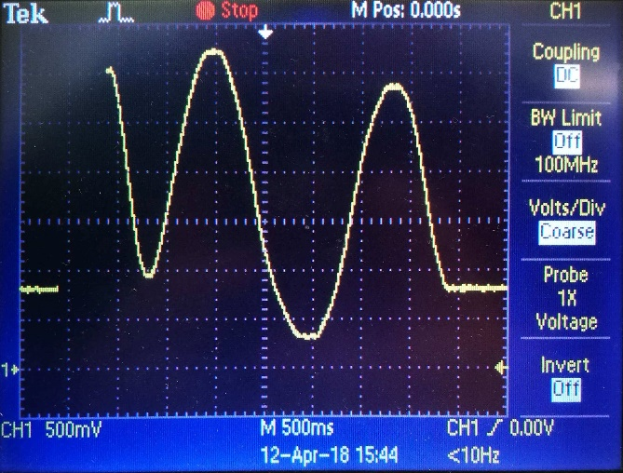

Appendix B – Gantt Chart Page 1

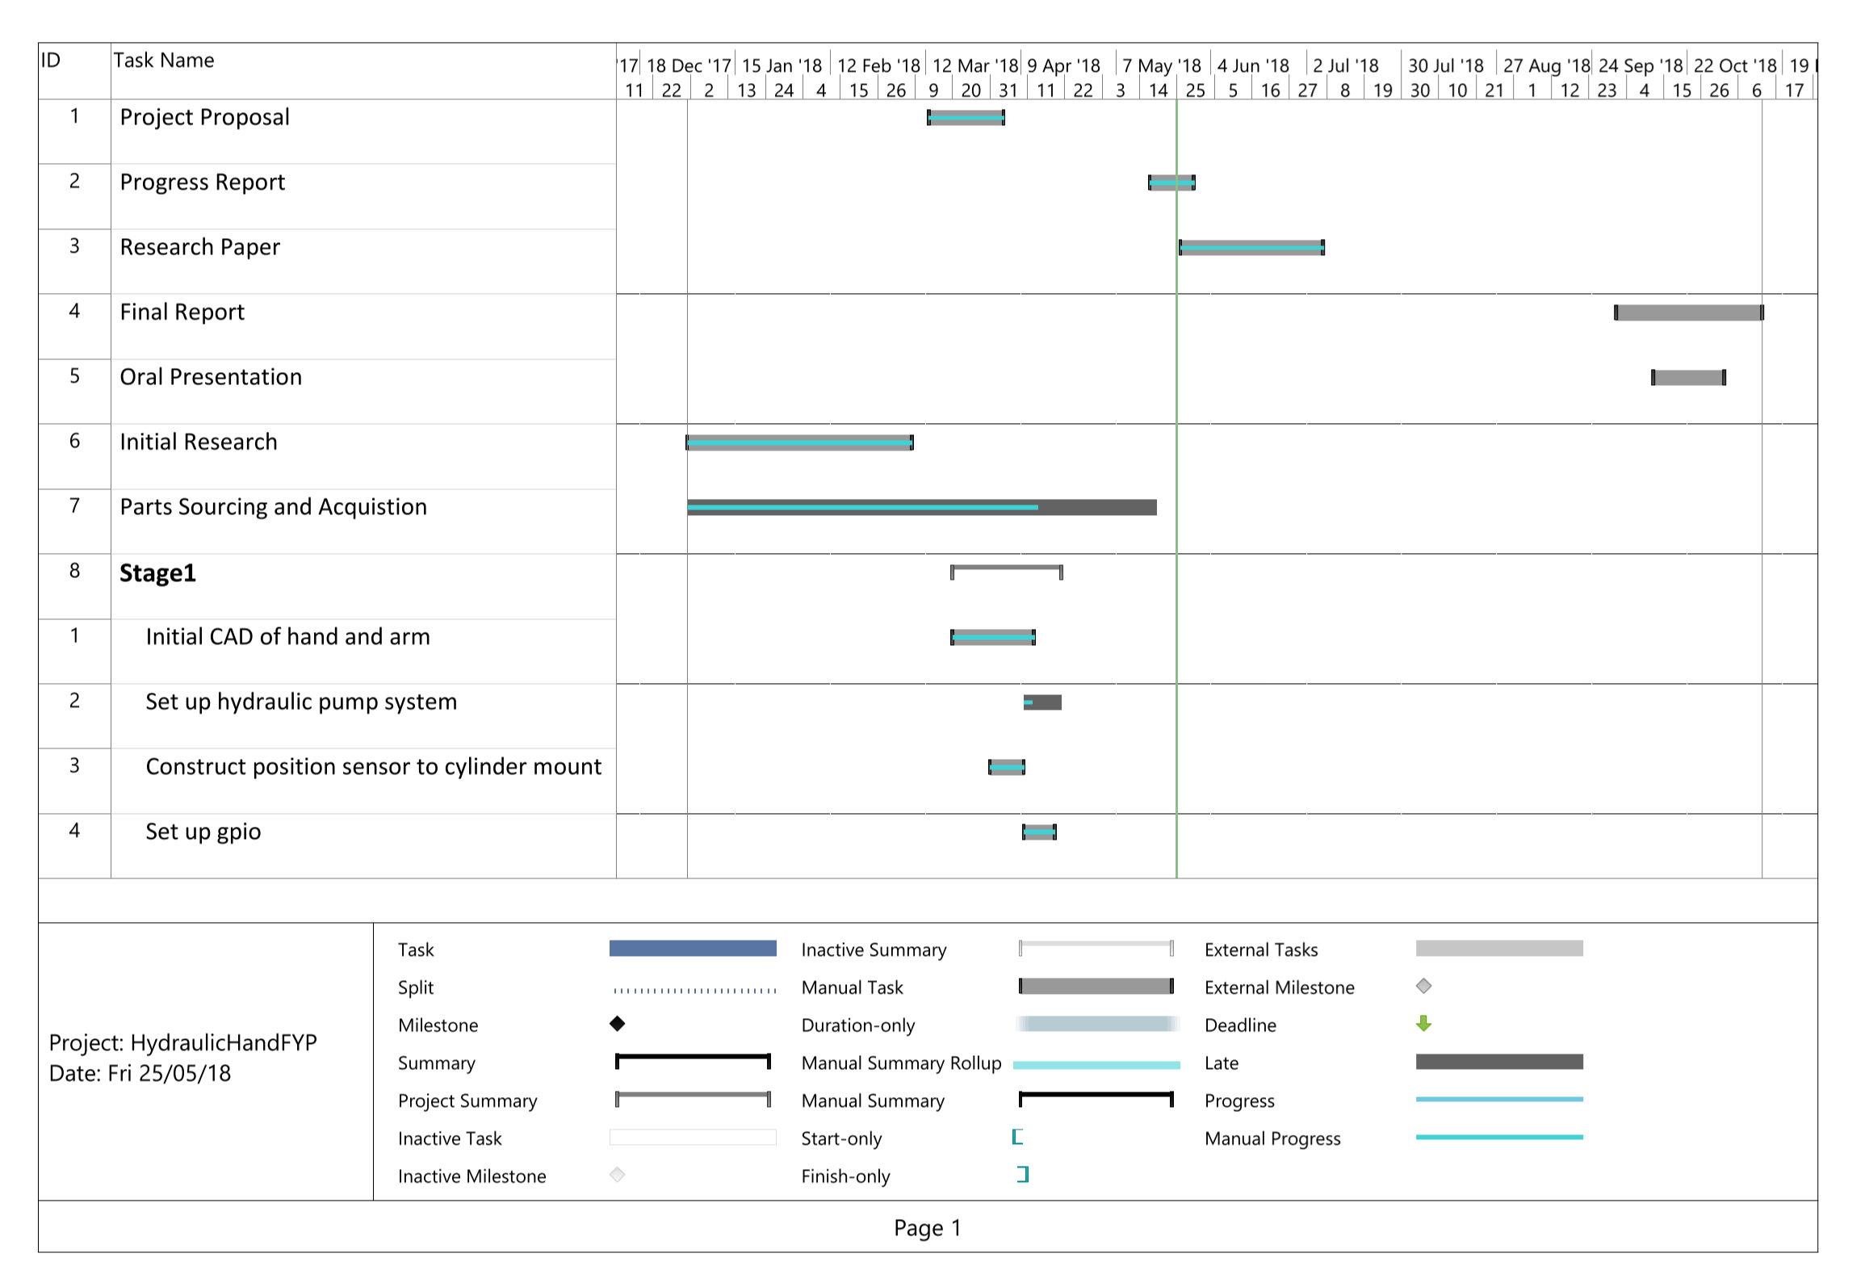

**Appendix C – Gantt Chart Page 2**

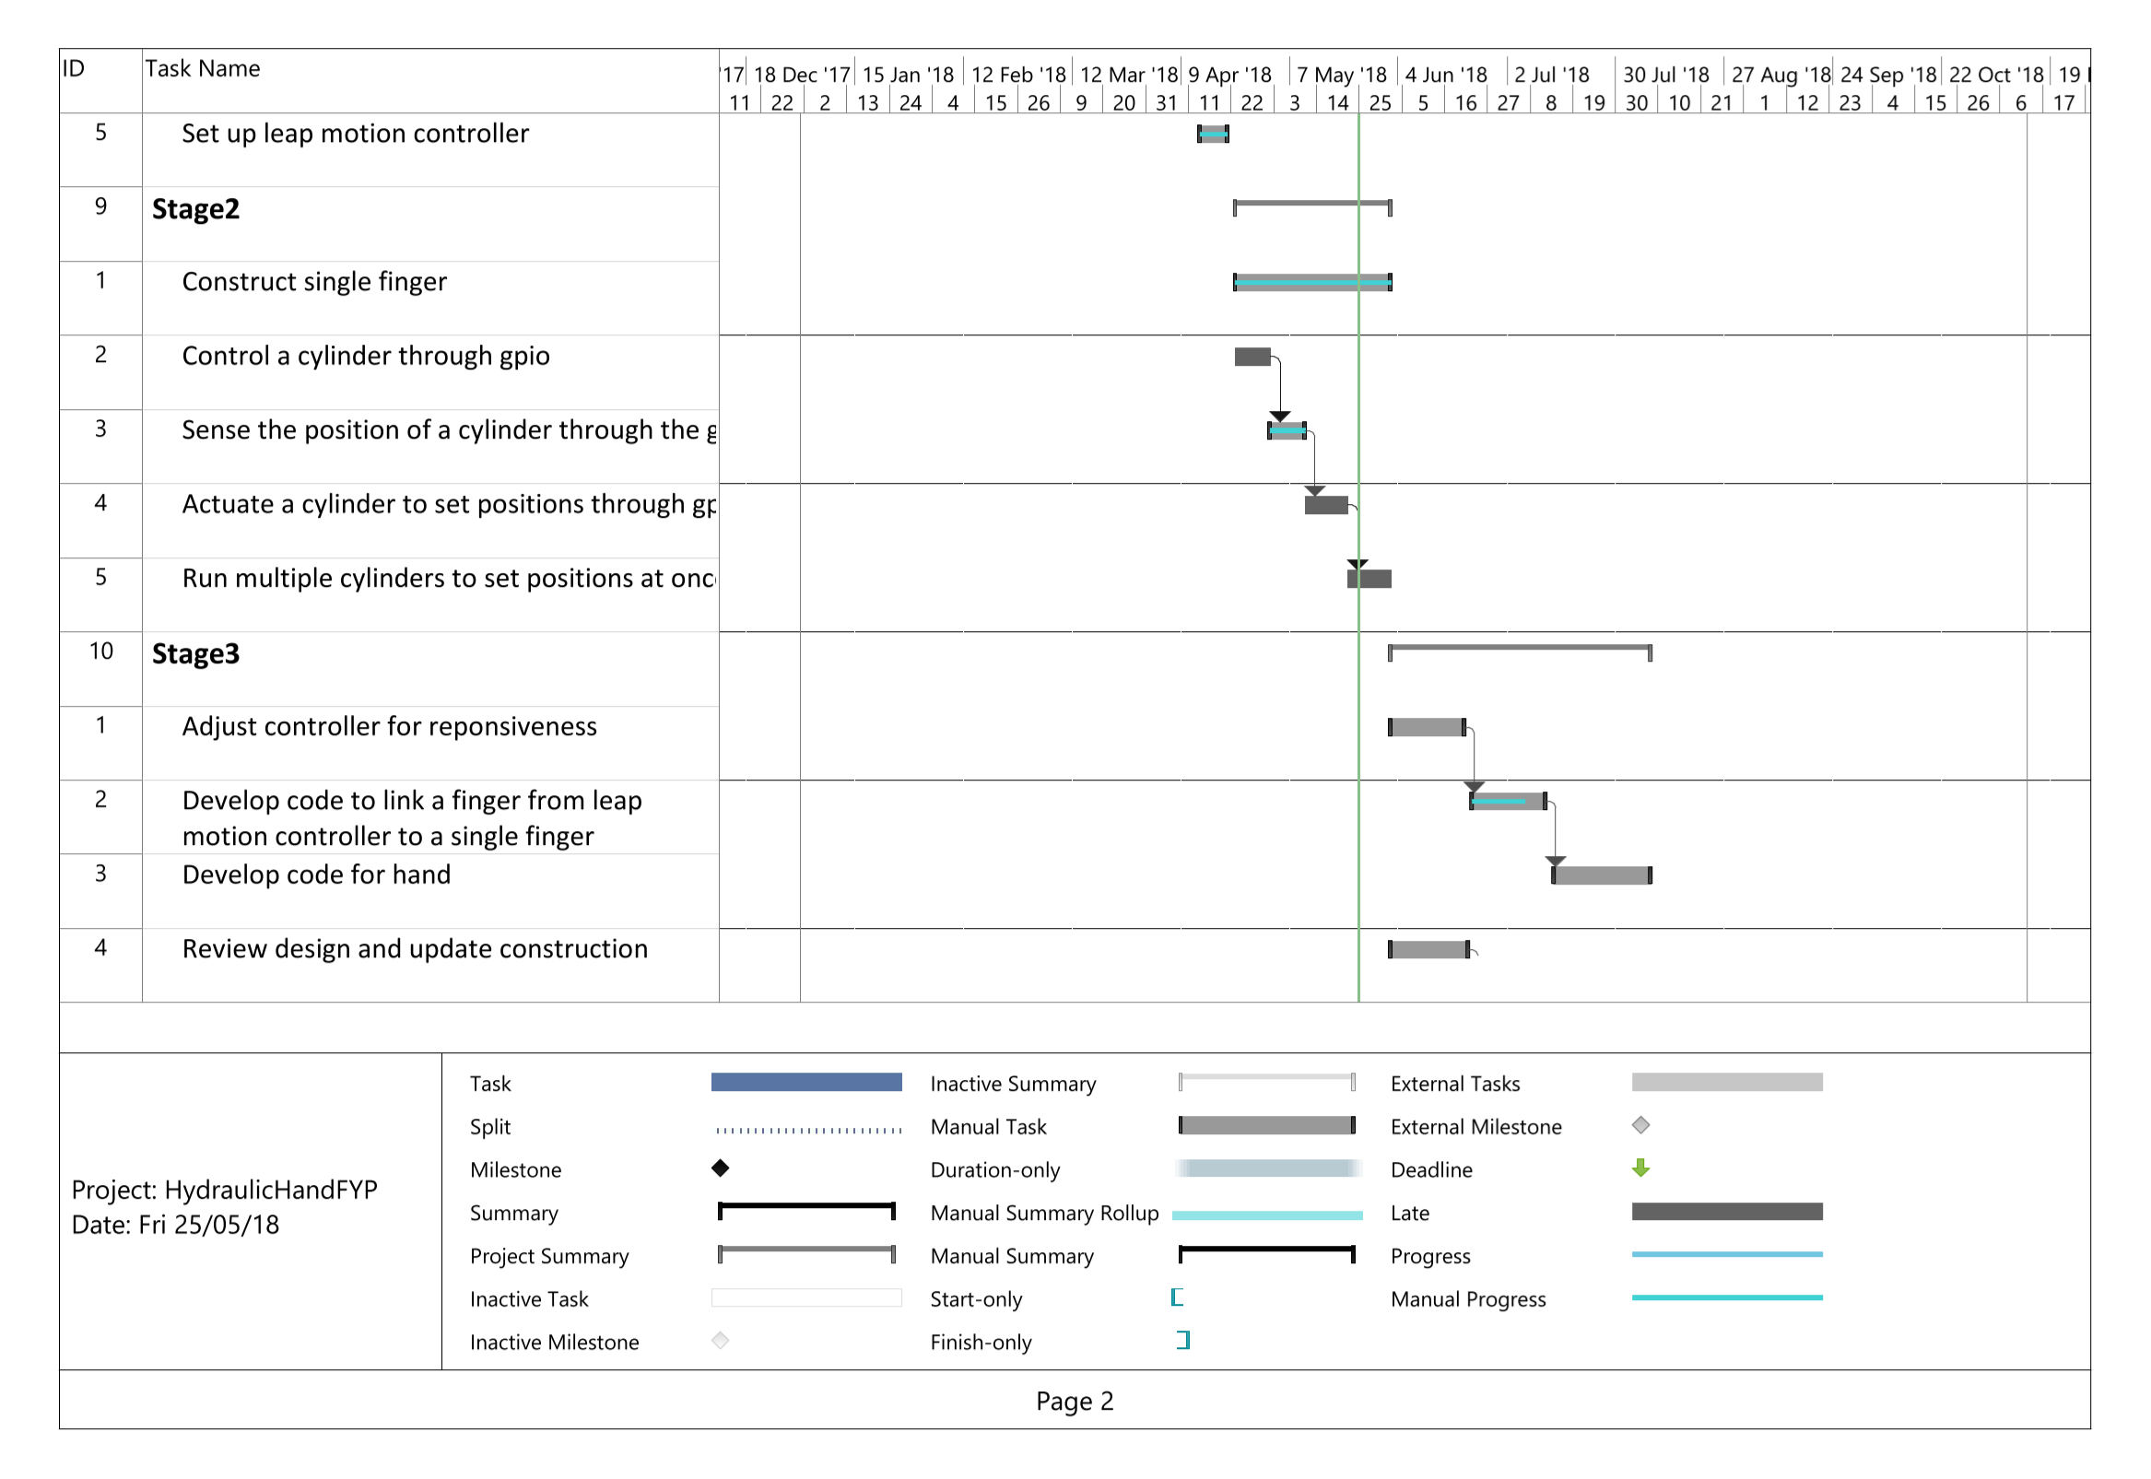

**Appendix D – Gantt Chart Page 3**

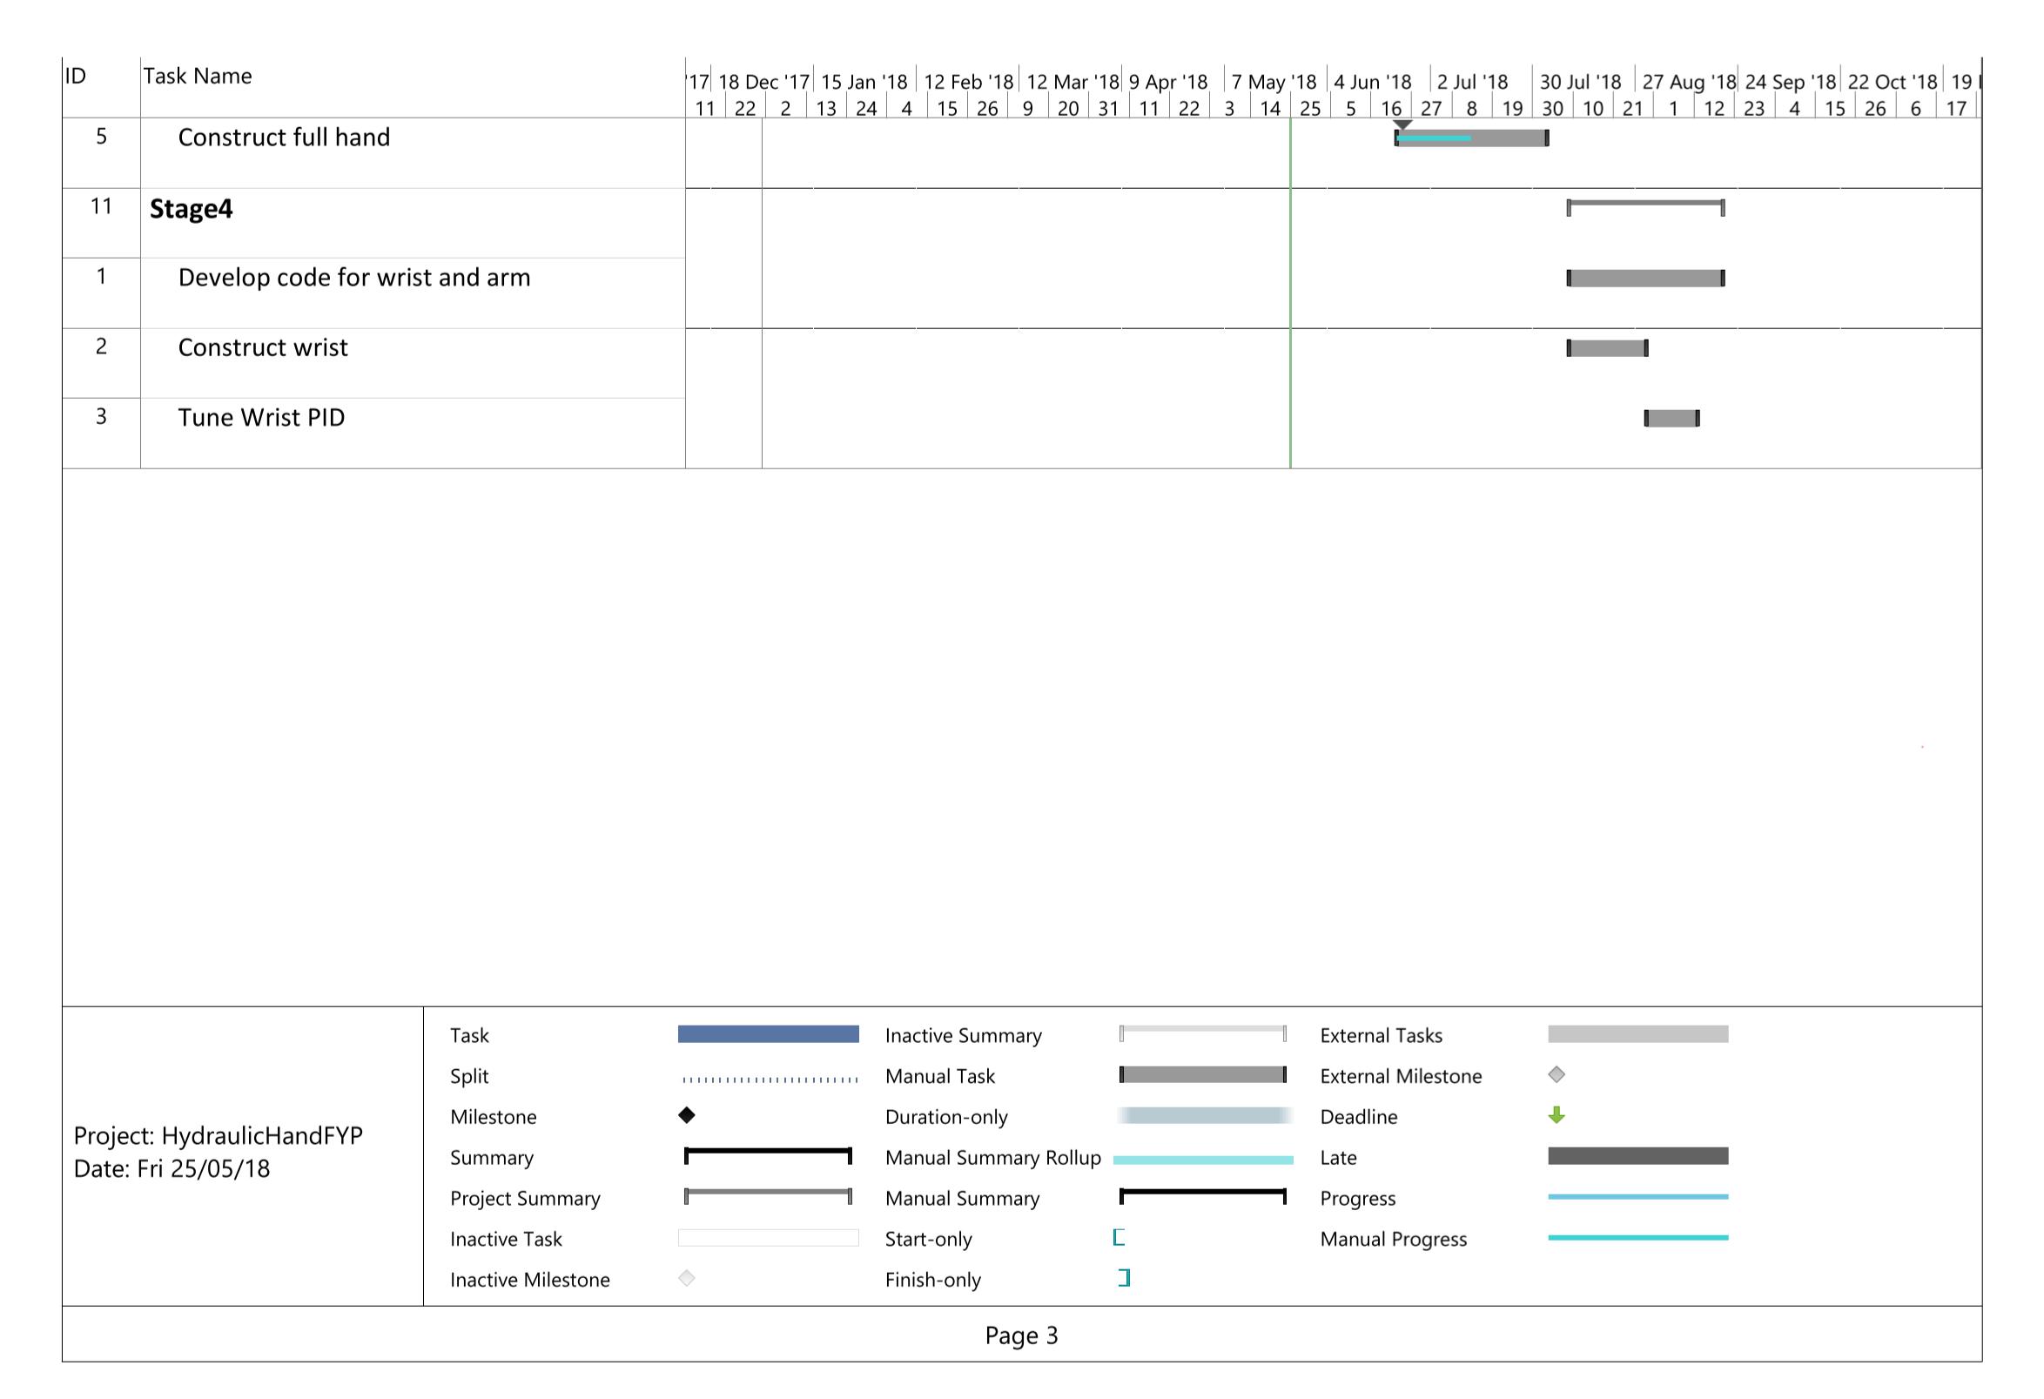

**Appendix E – Complete Hydraulic Schematic**

